Install Dirmaint

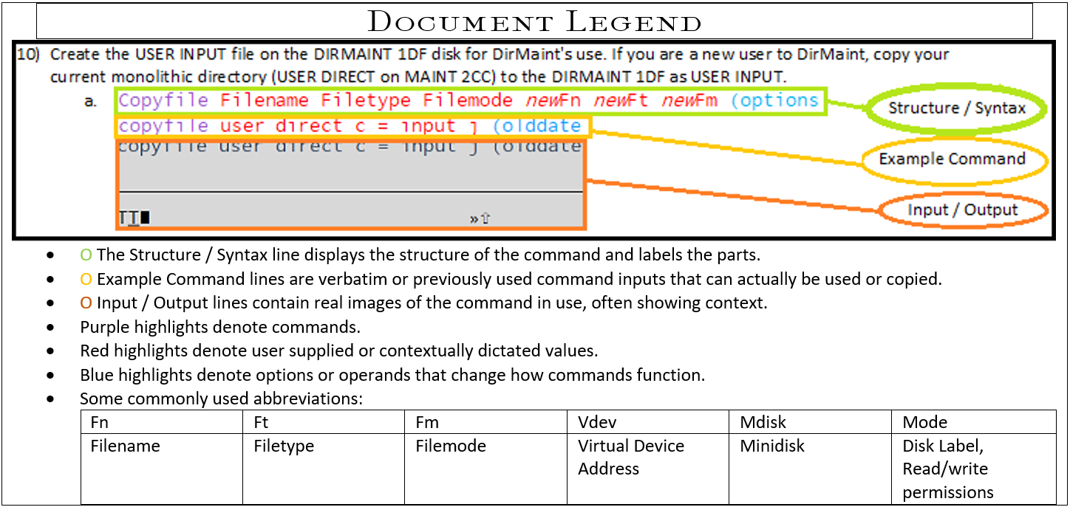

1. Log on to the MAINT730 user.
2. Set DirMaint to the enabled state.
   1. Service dirm operand  
      service dirm enable  
      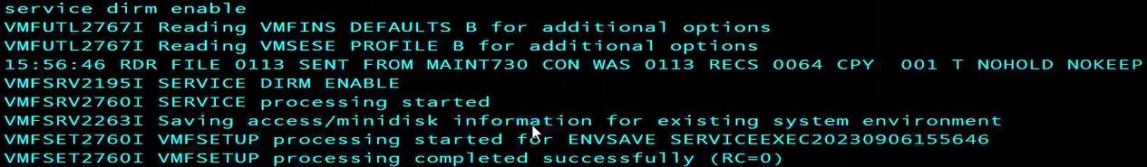
3. Create the LNKACCSS and CPYFRPLC executables using Xedit. Copy and paste the contents of the respective example files linked in this document to generate a useable executable which can be invoked by inputting the name in the command line with access.
   1. XEDIT *fn ft fm*  
      XEDIT *LNKACCSS EXEC A*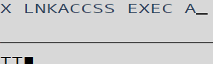
      1. Add *#*  
         Add 22  
         

* + 1. LNKACCSS EXEC
  1. XEDIT *fn ft fm*  
     XEDIT *CPYFRPLC EXEC A*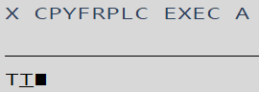
     1. Add *#*  
        Add 24  
        

* + 1. CPYFRPLC EXEC

1. Run LNKACCSS EXEC (Script Contents can be pasted into a new Xedit document, fn LNKACCSS ft EXEC)
   1. LNKACCSS filetype filemode  
      LNKACCSS EXEC A  
      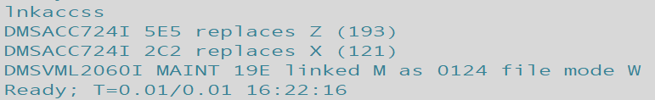
   2. Check the mdisk filemodes have been accessed with a query disk.  
      Query Operand  
      Query Disk  
      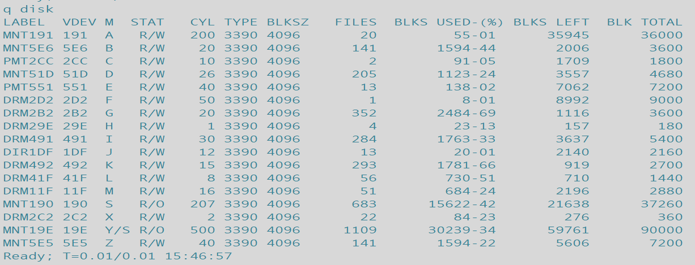

1. Create a product parameter override file (PPF) with XEDIT to set DIRMAINT’s runmode to operational. The override file for DIRM will have a filename of CONFIGxx (example CONFIG99) where x is a user selected value for identification and a filetype of DATADVH. Files are used in reverse alphabetical. Thus Config99 will run before ConfigAA Copy or save this file to the DIRMAINT 41F mdisk. Create Authfor Control with Xedit in the same manner.
   1. XEDIT *fn ft fm*  
      XEDIT *CONFIGxx DATADVH A*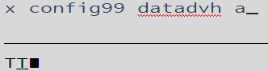
      1. Add *#*  
         Add 3  
         
      2. Edit the new lines as shown below.  
         CONFIG99  
         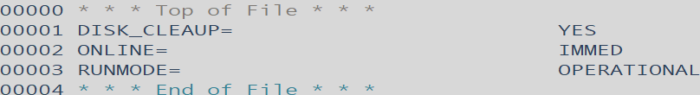
      3. Use File to save your changes.  
         
   2. Create the Authfor Control (<-example/contents hyperlinked) file and save it to your A disk for transfer at a later step. You will need to have an accessible user (typically Maint730 first) in order to perform administrative tasks once DIRM is set up.  
      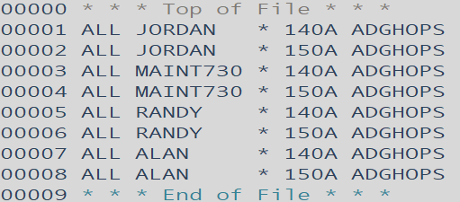
      1. XEDIT *fn ft fm*XEDIT *Authfor Control A*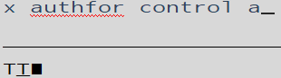
      2. Add #  
         add 8  
         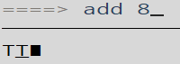
2. Generate, rename and relocate files on the DIRMAINT file list. To do this either:
   1. Run the CPYFRPLC EXEC.  
      CPYFRPLC EXEC A  
      
      1. ALTERNATIVELY: Gain write access to the listed mdisks on the left with link or vmlink with a *write option* then use the copyfile command to rename and relocate the file to the location on the 🡪 right. (Default location of sample files is 7VMDIR30 2C2.)
      2. Below is a table of the files that must be copied or generated and placed on a specific MDISK.

Filename Filetype Vdev 🡪 Filename Filetype Vdev

N/A N/A Xedit 🡪 Config99 DATADVH 41F  
DVHPROFD SAMPDVH 2C2 🡪 DVHPROFA DIRMAINT 492   
DVHPROFM SAMPDVH 2C2 🡪 DVHPROFM DATADVH 492   
DVHPROFS SAMPDVH 2C2 🡪 DVHPROFA DIRMSAT 492  
N/A N/A Xedit 🡪 AUTHFOR CONTROL 1DF   
EXTENT SAMPDVH 2C2 🡪 EXTENT CONTROL 1DF 🡨 All of these mdisks belong to 7VMDIR30  
LINUX SAMPDVH 2C2 🡪 LINUX PROTODIR 1DF ex. Link 7vmdir30 1df 1df wr  
LINDFLT SAMPDVH 2C2 🡪 LINDFLT DIRECT n/a acc 1df q  
PROFILE EXECSAMP 2C2 🡪 PROFILE EXEC 491 OR  
140CMDS SAMPDVH 2C2 🡪 140CMDS DATADVH 41F ex. Vmlink 7VMDIR30 41F (write  
150CMDS SAMPDVH 2C2 🡪 150CMDS DATADVH 41F   
ACCESS SAMPDVH 2C2 🡪 ACCESS SAMPDVH MAINT 19E  
AUTHDASD SAMPDVH 2C2 🡪 AUTHDASD DATADVH 492   
CMS SAMPDVH 2C2 🡪 CMS PROTODIR 1DF  
CMSDFLT SAMPDVH 2C2 🡪 CMSDFLT DIRECT N/A   
CONFIG SAMPDVH 2C2 🡪 CONFIG DATADVH 41F  
CONFIGRC SAMPDVH 2C2 🡪 CONFIGRC DATADVH 41F \***ConfigRC is for RACF, use only for RACF!!!!!**  
DATAMOVE SAMPDVH 2C2 🡪 DATAMOVE DATADVH 492   
DIRMAINT SAMPDVH 2C2 🡪 DIRMAINT DATADVH 492  
DIRMMAIL SAMPDVH 2C2 🡪 DIRMMAIL NEWMAIL 41F   
DIRMSAPI EXECSAMP 2C2 🡪 DIRMSAPI EXEC 41F  
DIRMSAT SAMPDVH 2C2 🡪 DIRMSAT DATADVH 492   
DVHNAMES SAMPDVH 2C2 🡪 DVHNAMES DATADVH 492

* + NOTE: These files may already be present, relocated and renamed- but REPLACE regardless.  
    ORIGINAL LIST HERE.
  + NOTE: CONFIGRC by default has YES ALL uncommented. Put a / in front of this if you don’t use RACF and pulled this file.
  1. After moving the files confirm they’ve been properly relocated and renamed by listing the files on the target mdisks: 41F=L, 492=K, 491=i, 1DF=J
     1. Filelist *fn* *ft* *fm*  
        Filel *\* * W*  
        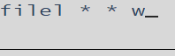
        1. The * symbol here is a wildcard. In this case it lists any filetype and name in mdisk(fm) W.

1. Run PUT2PROD to place any outstanding DirMaint service, such as a previously applied RSU, into production. Create the Authfor Control file which will act as the keyring for access to DIRMAINT commands. Copy the Authfor Control file to 7VMDIR30 41F mdisk.

* Important: If you are running in an SSI cluster you need to run PUT2PROD on every member before continuing with rest of these instructions. You need to do this as this is how DirMaint gets enabled on the other members.
  1. put2prod dirm  
     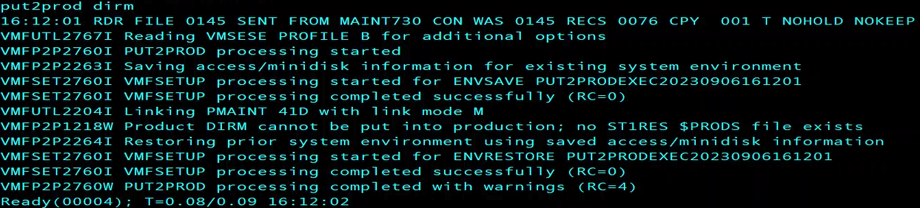

1. Overwrite DIRMAINT, DATAMOVE, and DIRMSAT user ID's Passwords. VMLINK to 2CC and change the passwords of these DIRM user ID’s to the default (Chosen at installation.) Leave any DATAMOV# or DIRMSAT# ID’s passwords unless in a cluster. Last, update and bring these changes online with directxa.
   1. Xedit *fn ft fm*Xedit *User Direct C  
      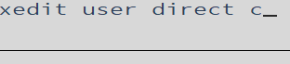*
   2. Operand */searchterm  
      /r dirmaint  
      *  finds 🡪 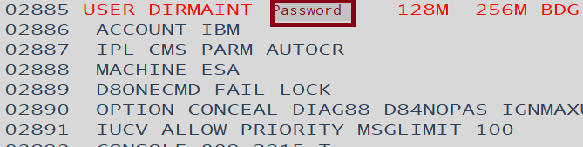
      1. Type the desired password *over* the old password.
   3. On the XEDITOR ====> command line use the FILE command to save changes to the file after overwriting the passwords.  
      FILE  
      
   4. Submit the changes and create the directory.  
      DIRECTXA  
      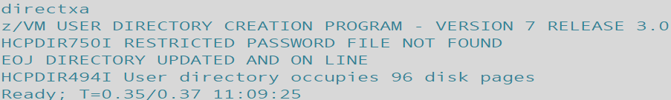
2. Access the disk where the DIR2PROD EXEC resides as well as certain DirMaint server and 7VMDIR30 test build minidisks which contain your production tailorable system files using the DIR2PROD exec. Use LINK and ACCESS commands to assign appropriate file modes and gain access. Confirm mdisk access and filemodes match with query.
   * 1. Running the script may not be necessary but confirms the correct filemodes.
   1. dir2prod access_new *7VMDIR30* DIRM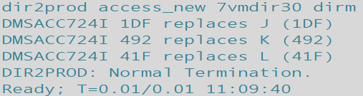
      1. Use DIRM if installing to minidisks or DIRMSFS if installing to SFS. In this example DIRM is used.
      2. Any missed mdisk access will be called out by the system, simply make the link and access it or correct the filemode as requested:  
         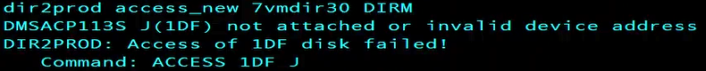
3. Create the USER INPUT file on the DIRMAINT 1DF disk for DirMaint's use. If you are a new user to DirMaint, copy your current monolithic directory (USER DIRECT on MAINT 2CC) to the DIRMAINT 1DF as USER INPUT.
   1. Copyfile Filename Filetype Filemode *new*Fn *new*Ft *new*Fm (options  
      copyfile user direct c = input j (olddate  
      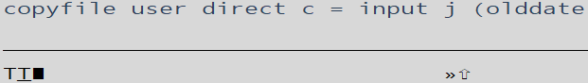
      1. The directory is monolithic when all the user information is in one file i.e. the User Withpass file. Rather than a list of specific lines of information like the user direct file created by directxa.
4. Query whether any of the DirMaint server machines, DIRMAINT, DATAMOVE, or DIRMSAT, are logged on, you need to log them off. Access the disk where the DIR2PROD EXEC resides, 7VMDIR30 492 as E. Copy code from the test minidisks to the production minidisks. If you are running in an SSI cluster you need to log onto each member of the cluster and run this command as it updates the MAINT 19E disk.
   1. Query operand  
      Q name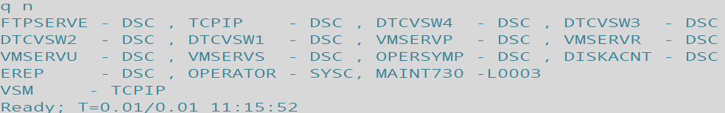
   2. Dir2prod operand user type  
      dir2prod update_files *7VMDIR30* DIRM  
      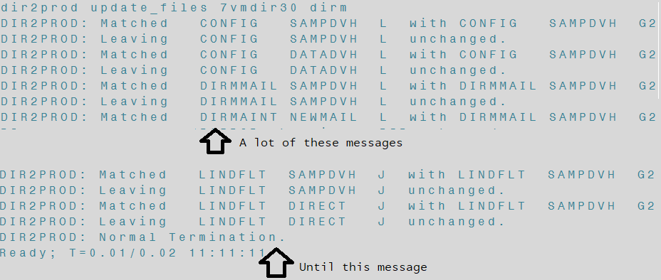
   3. Instruct DIRMAINT to place user tailored files into production. (Most mdisk’s for dirmaint have a front and back end version- one that is in active use/ can be used to place edited files, and the file set DIRMAINT uses as a record and for placing things into production.)
      1. Dir2prod operand user type  
         dir2prod prod *7VMDIR30* DIRM  
         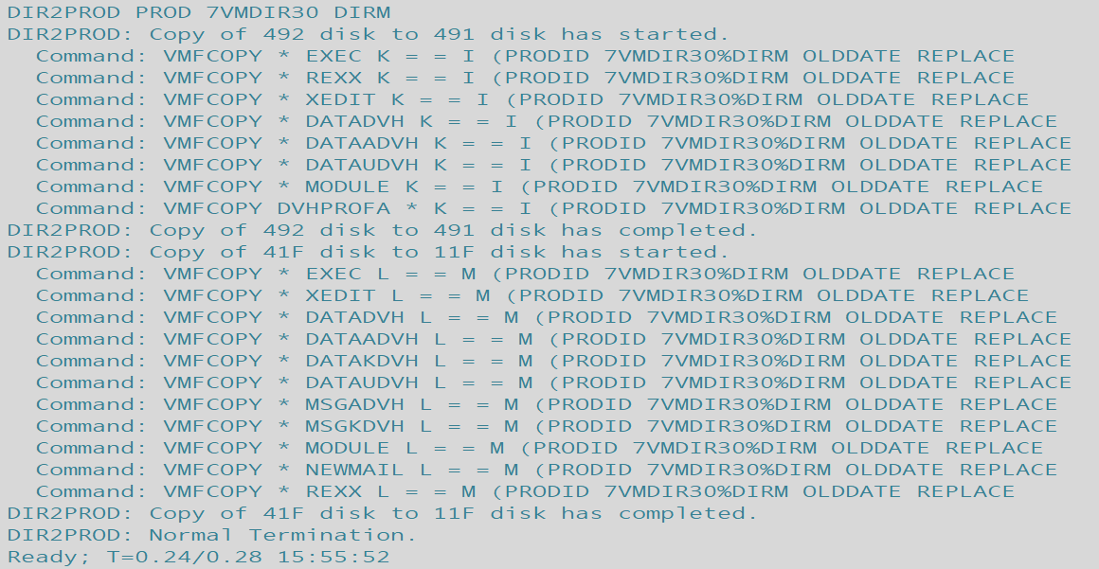
5. Logon to the DIRMAINT server. Verify it is working. It should prompt the user to start work by inputting, “DVHBEGIN”
   1. Dvhbegin  
      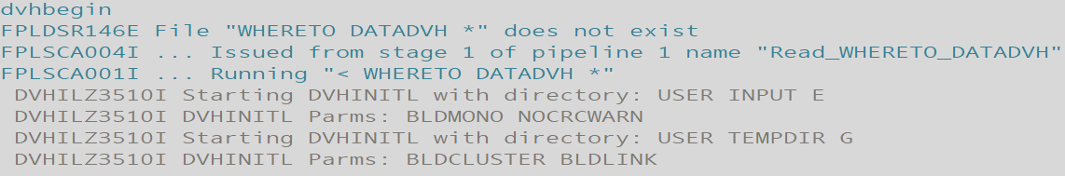
      1. After DIRMAINT finishes initializing and setting up, output should display as such:  
         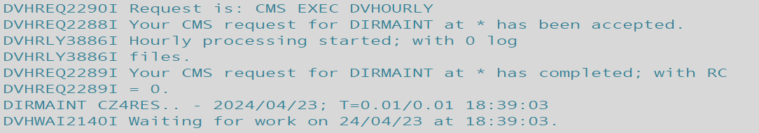
   2. IF DIRMAINT DOES NOT initialize properly and does NOT give the waiting for work message time to troubleshoot:  
      
      1. IMPORTANT if you receive, “WHERETO DATADVH not found” it’s because you did not copy the user direct from 2cc to 1df.
      2. Should you receive a DVHNAME message, it is most likely that one or more of the files to be tailored and copied was not properly done.
      3. If DIRMAINT wasn’t running recently or this is the first begin submitted since IPL there may be a flood of messages, “More…” - simply Clear key through them to the end (slowly enough for Reflections to take screengrabs.)
      4. If you see message 'DVHITI3531W An OFFLINE CONTROL exists...’ a file: OFFLINE CONTROL is holding changes.   
         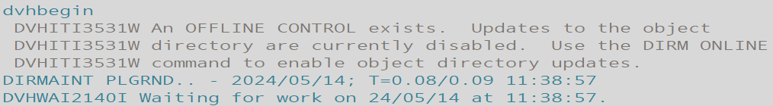
         1. Otherwise you must later issue DIRM ONLINE from an authorized user before automatic object directory updates will occur.
         2. Issue ONLINE if you want to enable object directory updates according to the ONLINE= configuration statement.  
            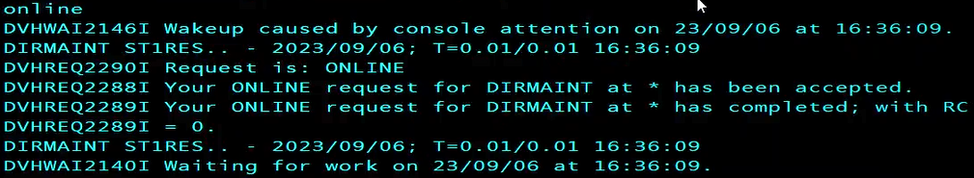
   3. After you see the, “Waiting for work” message then disconnect the server by issuing:  
      #CP DISC  
      
6. Lastly link with the 7vmdir30 (_vmdir__ release specific user) and it’s 41F MDISK with write privileges to disable RACF’s default YES ALL setting within ConfigRC DATADVH by placing a ‘/’ slash in the first column of the statement. (Alternatively you can just delete the file or simply don’t make it/transfer it during this process.)
   1. Form the mdisk link.  
      vmlink user mdisk (options  
      vmlink 7vmdir30 41F (write  
      
   2. Open the ConfigRC Datadvh file in xeditor.  
      xedit filename filetype filemode  
      x configrc datadvh z  
      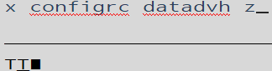
   3. Search for, “YES ALL” or navigate to line 97, which should be the only uncommented statement.  
      /Searchterm  
      /YES ALL  
      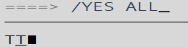
   4. Place a, ‘/’ slash in the first column, effectively disabling the statement and RACF (assuming you do **not** wish to use RACF.)  
      /  
      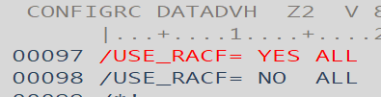
   5. File and save your changes.  
      File  
      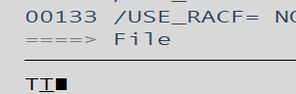
7. Congrats, you now have an immediately online, hourly, daily checking fully functional DIRMAINT installed and in active use!

File Tables:  
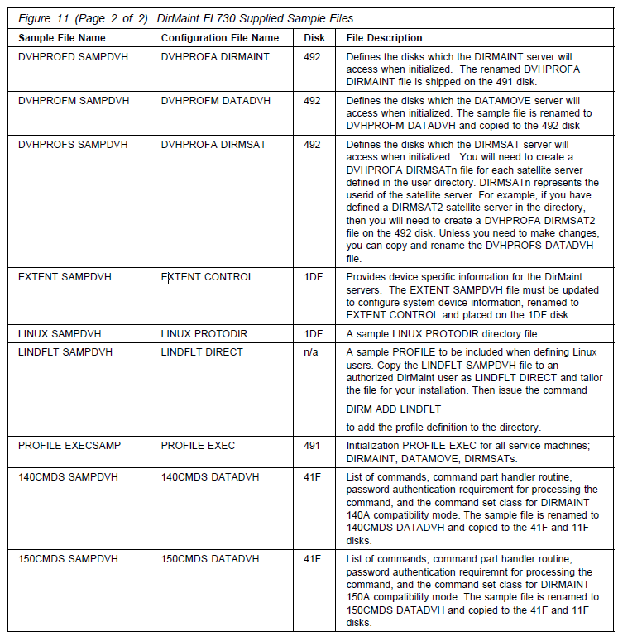  
1 of 2  
  
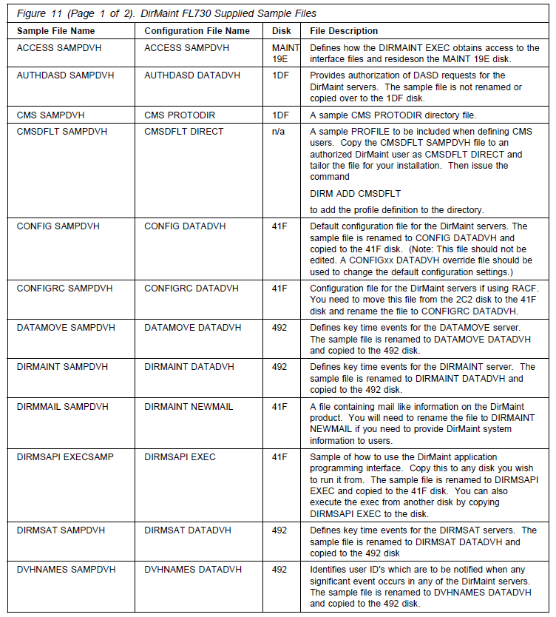  
2 of 2

**Return to current step.**

***LINK AND ACCESS***

LNKACCSS EXEC script:  
  
/* Link and Access for DIRM Install */

'link maint 5e5 5e5 wr'

'acc 5e5 z'

'link 7vmdir30 491 491 wr'

'acc 491 i'

'link 7vmdir30 492 492 wr'

'acc 492 k'

'link 7vmdir30 41f 41f wr'

'acc 41f l'

'link 7vmdir30 2c2 2c2 wr'

'acc 2c2 x'

'link 7vmdir30 2b2 2b2 wr'

'acc 2b2 g'

'link 7vmdir30 2d2 2d2 wr'

'acc 2d2 f'

'link 7vmdir30 29e 29e wr'

'acc 29e h'

'link 7vmdir30 1df 1df wr'

'acc 1df j'

'LINK 7VMDIR30 11F 11F WR'

'ACC 11F M'

'VMLINK MAINT 19E (WRITE'

Return to instruction steps (top)

***USER GENERATED FILES:* Create these in Xedit after establishing Link and Access, read and write permissions.**  
  
Authfor Example:  
ALL JORDAN * 140A ADGHOPS

ALL JORDAN * 150A ADGHOPS

ALL MAINT730 * 140A ADGHOPS

ALL MAINT730 * 150A ADGHOPS

ALL RANDY * 140A ADGHOPS

ALL RANDY * 150A ADGHOPS

ALL ALAN * 140A ADGHOPS

ALL ALAN * 150A ADGHOPS  
  
**Config99 DATADVH** example:  
RUNMODE= OPERATIONAL

ONLINE= IMMED

ONLINE_VIA_DELTA= ON

DISK_CLEANUP= YES

**Copyfile** section**:****CPYFRPLC EXEC:**

/* Copy and Replace Files for DIRM Install */  
‘copyfile config99 datadvh a = = l'

‘copyfile authfor control a = = j (replace’

‘copyfile dvhprofd sampdvh x dvhprofa dirmaint k (replace’

‘copyfile dvhprofm sampdvh x dvhprofm datadvh k (replace’

‘copyfile dvhprofs sampdvh x dvhprofa dirmsat k (replace’

‘copyfile extent sampdvh x extent control j (replace’

‘copyfile linux sampdvh x linux protodir j (replace’

‘copyfile lindflt sampdvh x lindflt direct a’

‘copyfile profile execsamp x profile exec i (replace’

‘copyfile 140cmds sampdvh x 140cmds datadvh l (replace’

‘copyfile 150cmds sampdvh x 150cmds datadvh l (replace’

‘copyfile access sampdvh x access sampdvh w (replace’

‘copyfile authdasd sampdvh x authdasd datadvh k (replace’

‘copyfile cms sampdvh x cms protodir j (replace’

‘copyfile cmsdflt sampdvh x cmsdflt direct a’

‘copyfile config sampdvh x config datadvh l (replace’

/*‘copyfile configrc sampdvh x configrc datadvh l (replace’ */

‘copyfile datamove sampdvh x datamove datadvh k (replace’

‘copyfile dirmaint sampdvh x dirmaint datadvh k (replace’

‘copyfile dirmmail sampdvh x dirmmail newmail l (replace’

‘copyfile dirmsapi execsamp x dirmsapi exec l (replace’

‘copyfile dirmsat sampdvh x dirmsat datadvh k (replace’

‘copyfile dvhnames sampdvh x dvhnames datadvh k (replace’

Return to instructions